SESSION 1

Introduction to Databases
& Installation

Task 1 — Install MySQL Community Server and capture a screenshot
Answer / steps (Windows):
1. Open the official MySQL Community Server downloads page: https://dev.mysql.com/downloads/mysql/ . Choose the Windows package that matches your system and follow the official installation instructions.
2. Alternatively, for the MySQL 8.0 series, the official MySQL Installer can install MySQL Server and tools such as MySQL Workbench in one wizard: https://dev.mysql.com/downloads/installer/. The official page notes that MySQL Installer is the final installer series for MySQL 8.0; newer server releases use product-specific installers/configurators.
3. Run the installer and follow the prompts. If using MySQL Installer, choose a setup option that includes MySQL Server and MySQL Workbench (for example, Developer Default), if available.
4. Configure the server when prompted. Set and safely remember the root password. Keep the default port unless your setup requires another port. 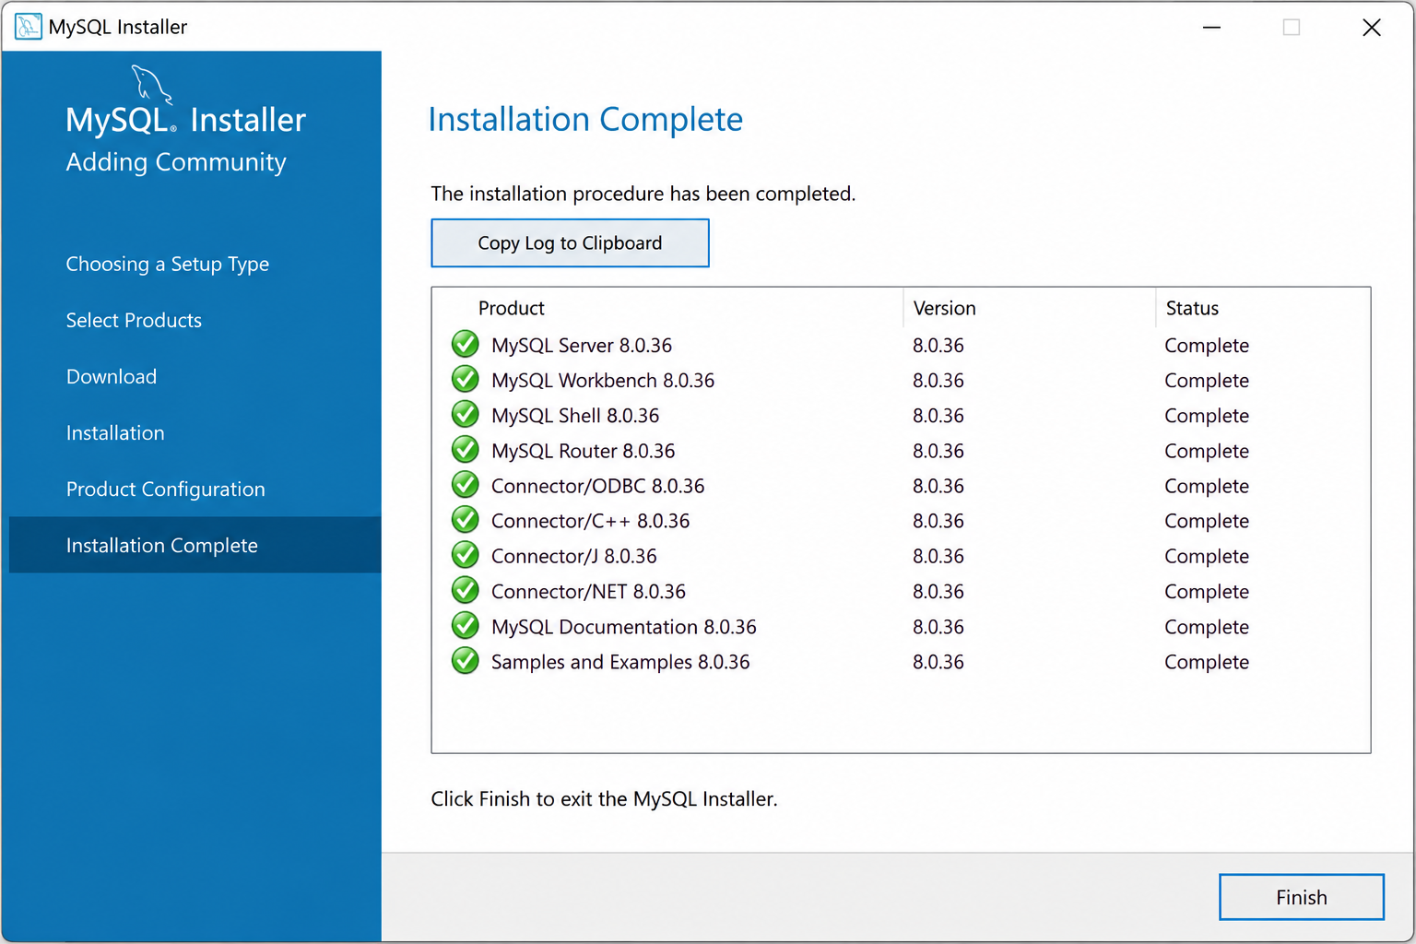

Task 2 — Connect to MySQL and create music_streaming_db
Use MySQL Workbench (recommended for this task). DB Browser for SQLite is designed for SQLite databases and does not connect directly to a MySQL Server.
1. Open MySQL Workbench.
2. Click your local MySQL connection (often named Local instance MySQL). Enter the root password when requested.
3. Open a new SQL query tab, type the command below, and click the lightning-bolt Execute button.
4. Run SHOW DATABASES; to confirm that the database appears. Then run USE music_streaming_db; to make it the active database.
CREATE DATABASE music_streaming_db;
SHOW DATABASES;
USE music_streaming_db;

Explanation
- CREATE DATABASE music_streaming_db; creates a new database with that name.
- SHOW DATABASES; lists the databases available on the connected MySQL server.
- USE music_streaming_db; selects the database for subsequent commands in the current session.

Task 3 — Create food_delivery_db
SQL command:
CREATE DATABASE food_delivery_db;

To verify and select it, run:
SHOW DATABASES;
USE food_delivery_db;

Explanation: CREATE DATABASE creates the database, SHOW DATABASES verifies that it is listed, and USE selects it as the current database. Execute these statements in MySQL Workbench after connecting to the server.

Task 4 — Three differences between MySQL and PostgreSQL
Comparison | MySQL | PostgreSQL
1. Database model | Commonly described as a relational DBMS. It is widely used for web applications and transactional workloads. | An object-relational DBMS, combining relational tables with additional object-relational capabilities.
2. Data types and extensibility | Supports common numeric, text, date/time, spatial, and JSON types. | Offers a broad set of types such as arrays, ranges, network addresses, and user-extensible types, functions, and operators.
3. Feature emphasis / use cases | Often selected for website backends, e-commerce, and applications where a practical, widely supported relational database is needed. | Often selected for complex queries, specialised data models, data integrity needs, and extensions such as PostGIS for geospatial work.

These are typical differences and use-case tendencies, not strict limits. Both systems can serve many of the same kinds of applications; the better choice depends on the workload, architecture, operational needs, and team experience.

Popular company/app examples
- MySQL: Spotify is listed among MySQL customers on the official MySQL website. See the MySQL Customers page in the references.
- PostgreSQL: Instagram has publicly documented its use of PostgreSQL in its backend/scale-up story. Large companies may use multiple databases, and their architecture can change over time.

Quick Revision
Command / concept | Remember
Database | An organised collection of information.
RDBMS | Manages relational data stored in tables.
SQL | Used to define, query, and manipulate data.
CREATE DATABASE database_name; | Creates a new database.
SHOW DATABASES; | Lists databases on the connected MySQL server.
USE database_name; | Selects the current database.
MySQL Workbench | A graphical tool for connecting to MySQL Server and running SQL.

Official / supporting references
- MySQL Community Server downloads: https://dev.mysql.com/downloads/mysql/
- MySQL Installer downloads and version note: https://dev.mysql.com/downloads/installer/
- MySQL Installer Guide: https://dev.mysql.com/doc/mysql-installer/en/
- MySQL customers (includes Spotify listing): https://www.mysql.com/customers/
- PostgreSQL: What Is PostgreSQL?: https://www.postgresql.org/docs/current/intro-whatis.html
- PostgreSQL project overview: https://www.postgresql.org/about/
- Instagram and PostgreSQL at scale (EDB article): https://www.enterprisedb.com/blog/instagram-scales-postgres
- AWS comparison: MySQL vs PostgreSQL: https://aws.amazon.com/compare/the-difference-between-mysql-vs-postgresql/

